Exercise 2: Implementing Dependency Injection
Scenario:
In the library management application, you need to manage the dependencies between the BookService and BookRepository classes using Spring's IoC and DI.
Implementation:

applicationContext.java
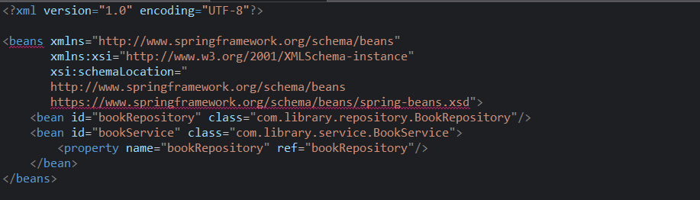

BookService.java
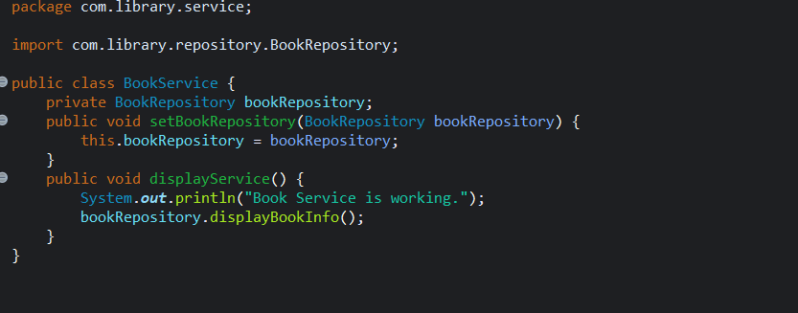

BookRepository.java
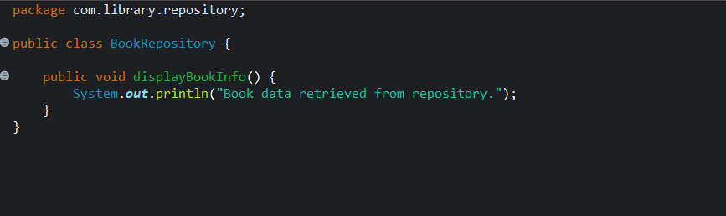

LibraryApplication.java
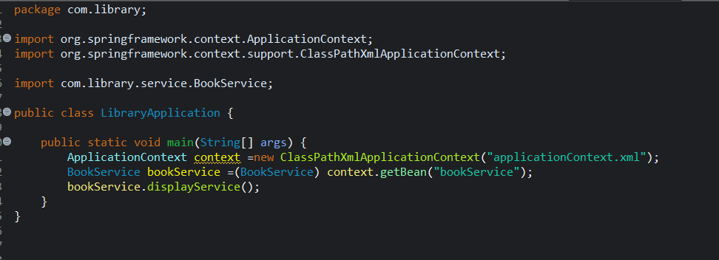

OUTPUT:
